Q7 Create a simple cloud software application for Students Attendance System using any Cloud Service Provider to demonstrate SaaS include the necessary fields such as name of the students, course, present , Absent, course attendanc request, grade, attendance percentage, etc.

# CREATING STUDENT DETAILS   
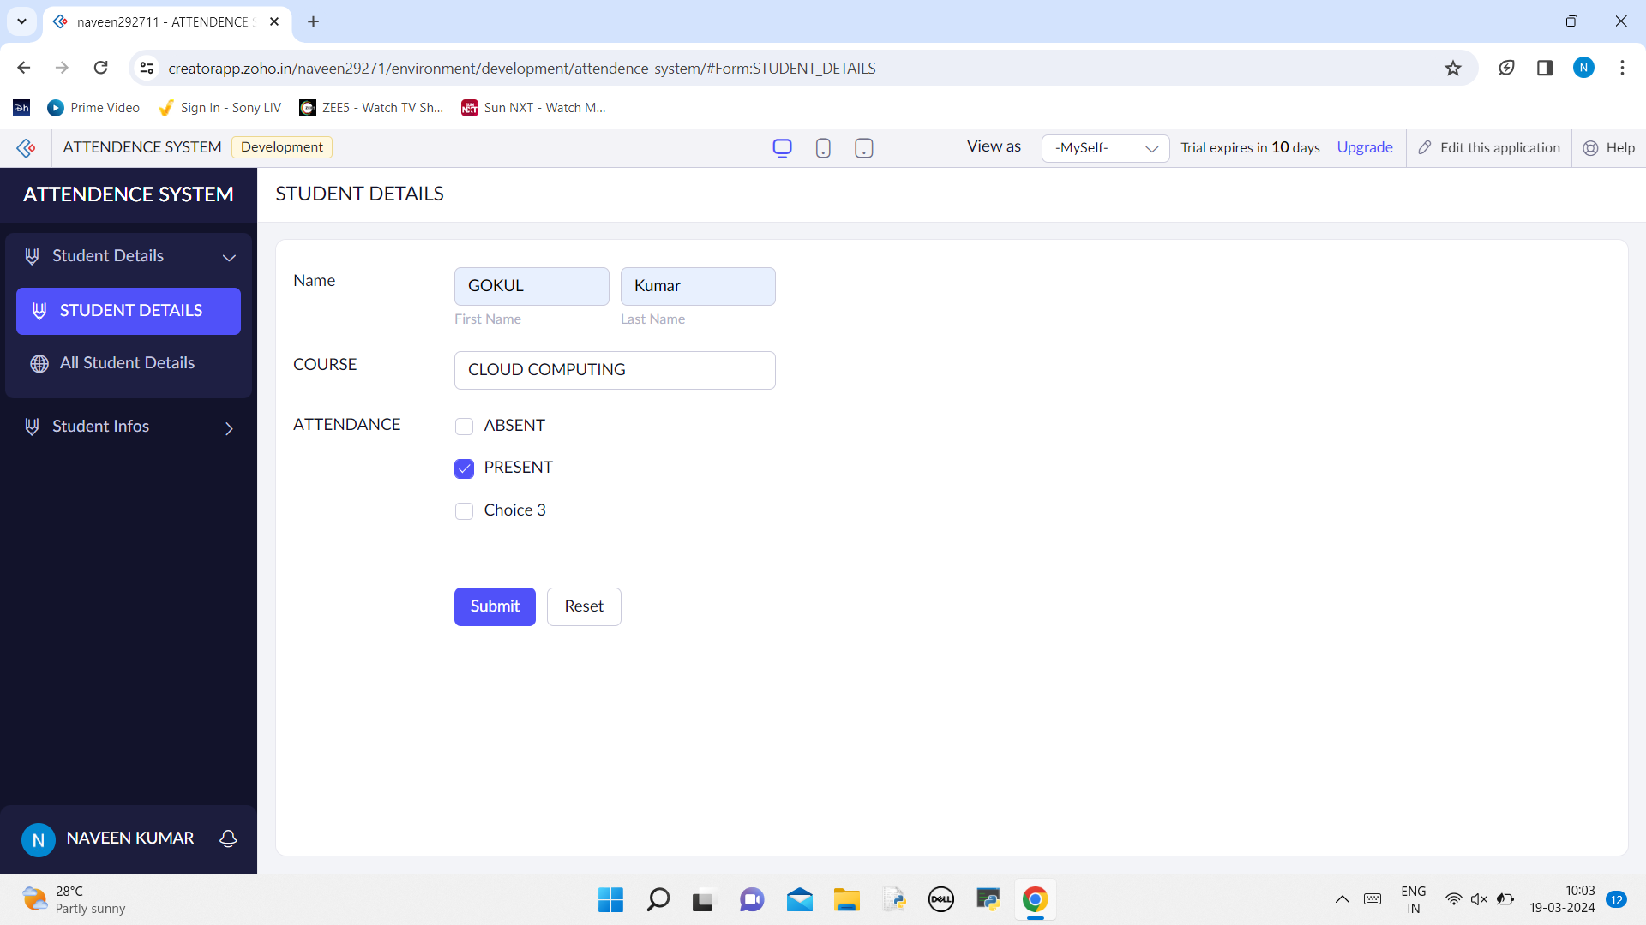

# LIST OF STUDENT DETAILS   
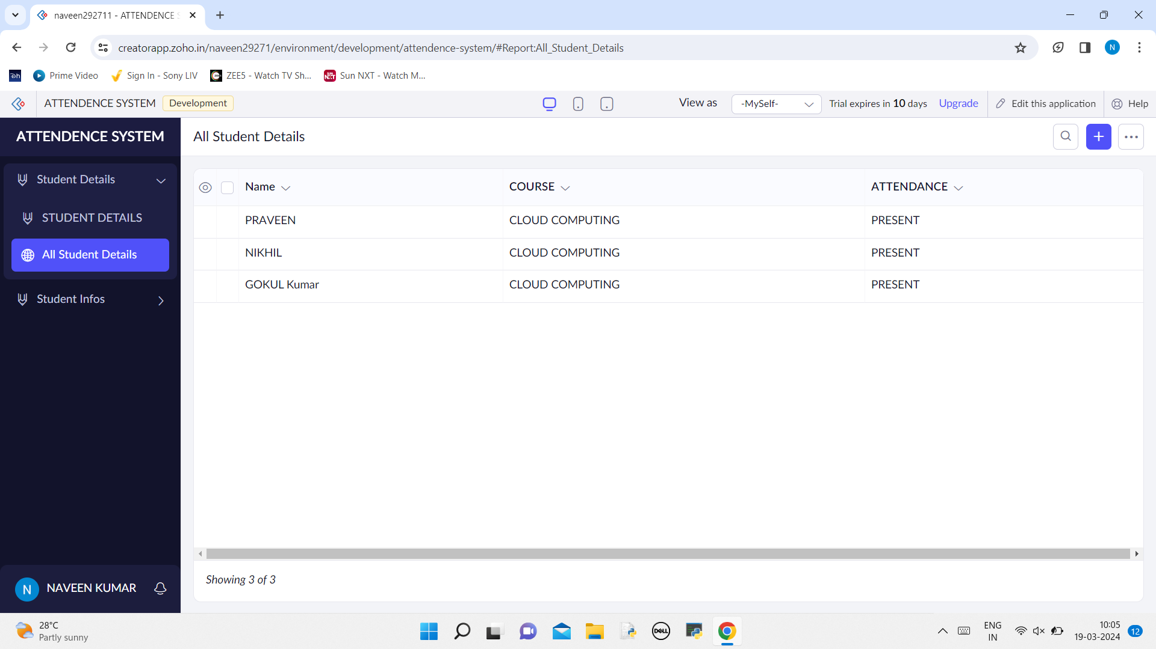

# CREATING STUDENT INFO  
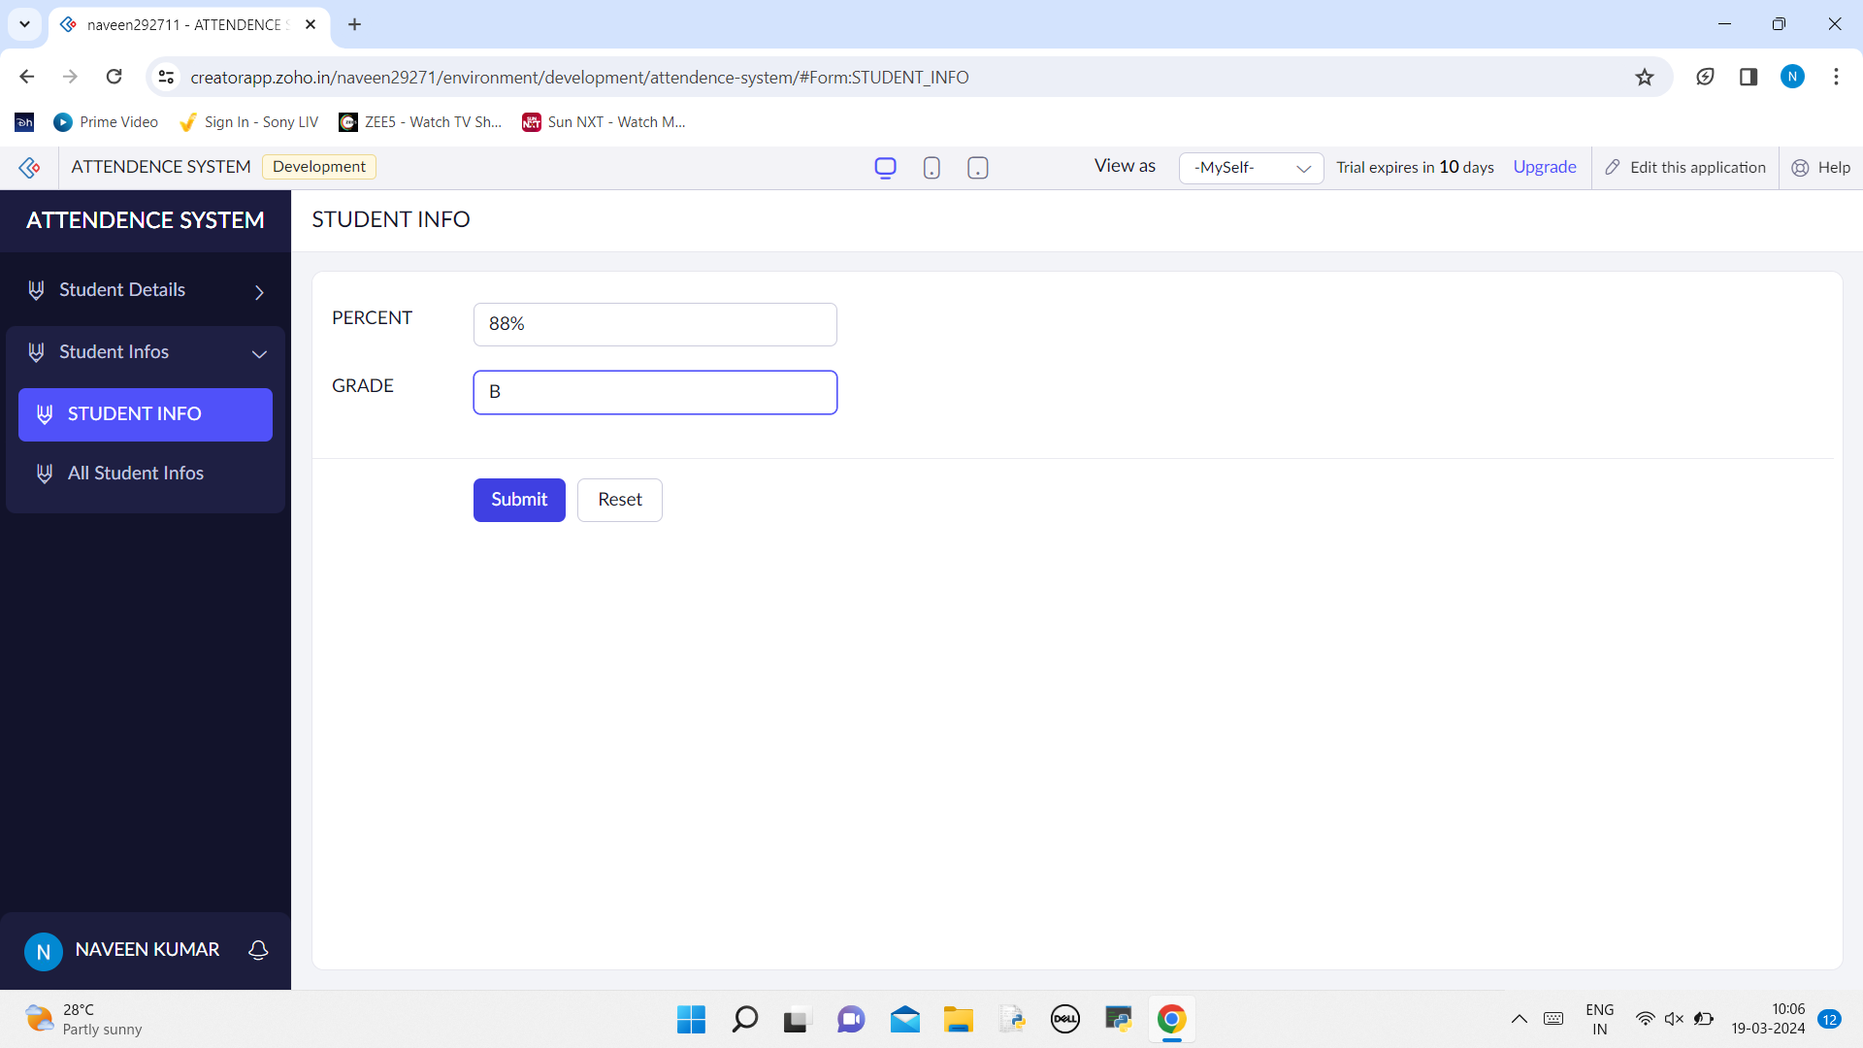

# LIST OF STUDENT INFO IS DISPLAYED   
